Project Design Phase-II
Technology Stack (Architecture & Stack)

Date | 20 February 2026
Team ID | TVIP2026TMIDS41611
Project Name | OrderOnTheGo: Your On-Demand Food Ordering Solution
Maximum Marks | 4 Marks

Technical Architecture:

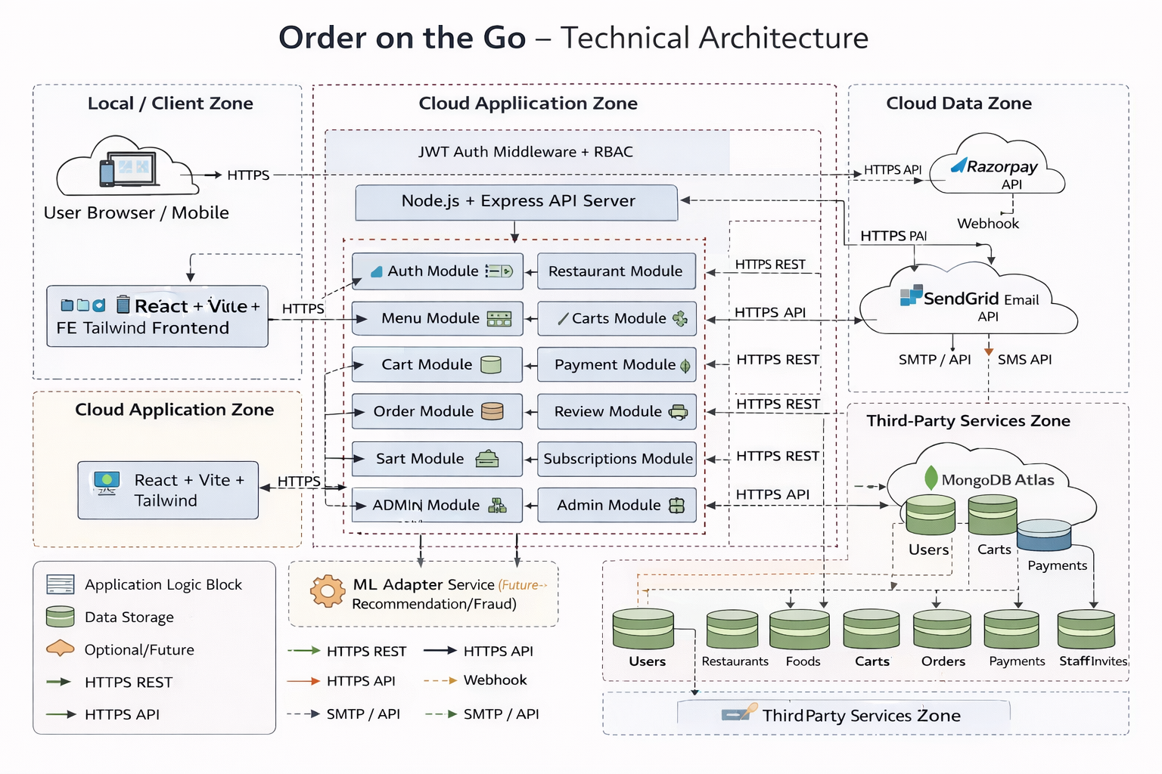

Table-1 : Components & Technologies:
S.No | Component | Description | Technology
 | User Interface | Web interface for customers, restaurant owners, staff, and admin dashboards | React, Vite, Tailwind CSS, Axios, HTML5, CSS3, JavaScript
 | Application Logic-1 | Core business APIs: authentication, menu, cart, order lifecycle, reviews | Node.js, Express.js, JavaScript, REST APIs
 | Application Logic-2 | Access control and workflow enforcement: JWT auth, role-based access, subscription limits | JWT, Express middleware, Mongoose validation/hooks
 | Application Logic-3 | Payments and communication orchestration: payment create/verify, email/SMS verification | Razorpay SDK/API, SendGrid API, Twilio API
 | Database | Operational data model for users, restaurants, foods, carts, orders, payments, reviews, subscriptions | MongoDB (NoSQL document DB), Mongoose ODM
 | Cloud Database | Managed cloud database for production persistence and backup | MongoDB Atlas
 | File Storage | User/restaurant profile image handling and file uploads | Local filesystem (uploads/profiles), optional cloud object storage (recommended: IBM COS / S3 / Azure Blob)
 | External API-1 | Online payment order creation, signature verification, transaction status | Razorpay Payment Gateway API
 | External API-2 | Customer communication for account verification and notifications | SendGrid Email API, Twilio SMS API
 | Machine Learning Model | Currently not implemented; future option for recommendations, fraud/risk scoring, demand prediction | Recommended: Python ML service (scikit-learn/TensorFlow) exposed via REST, or cloud ML endpoint
 | Infrastructure (Server / Cloud) | Local: React dev server + Node/Express + local/Atlas DB. Cloud: frontend static hosting + API server + managed DB + third-party integrations | Local VM/dev machine; Cloud options: Kubernetes, App Service/Cloud Foundry equivalent, Docker, managed MongoDB Atlas

Table-2: Application Characteristics:
S.No | Characteristics | Description | Technology
 | Open-Source Frameworks | Full-stack open-source web architecture for rapid delivery and maintenance | React, Vite, Tailwind CSS, Node.js, Express.js, Mongoose
 | Security Implementations | Token-based auth, RBAC, credential hashing, verification flows, API protection baseline | JWT, bcrypt password hashing, role-based authorization middleware, CORS policy, HTTPS (production), environment secrets, OTP/email verification
 | Scalable Architecture | Modular 3-tier architecture (UI, API, DB), domain-based controllers/routes, horizontal API scaling path | React SPA + Express modular monolith + MongoDB Atlas; containerization-ready with Docker/Kubernetes
 | Availability | Production-ready by deploying multiple API instances and managed DB with replication/backups | Load balancer + multi-instance Node API, MongoDB Atlas replica set, process manager/restart policy (PM2/Docker), health checks
 | Performance | Fast API response through indexed queries, pagination, lean payloads, and static asset optimization | MongoDB indexes, pagination/filtering, efficient Mongoose queries, Vite optimized build, CDN for static assets/images (recommended), Redis cache (recommended)

References:
https://c4model.com/
https://developer.ibm.com/patterns/online-order-processing-system-during-pandemic/
https://www.ibm.com/cloud/architecture
https://aws.amazon.com/architecture
https://medium.com/the-internal-startup/how-to-draw-useful-technical-architecture-diagrams-2d20c9fda90d

